TABLE OF CONTENTS
1.0 PURPOSE 1
2.0 SCOPE 1
3.0 reference documents 1
3.1 TI Standard Policy and Procedure (SP&P) 04-04-01: "Environmental, Health and Safety" 1
3.2 TI ESH Standard 04.01: “Electrical Safety” 1
3.3 TI ESHMS 4.4.2 “Competence, Training and Awareness” 1
4.0 Definitions 1
5.0 Requirements 1
5.1 General Requirements 1
5.2 Pre-Task Fall Hazard Assessment 2
5.3 Fall Restraint Systems 2
5.4 Fall Arrest Systems 3
5.5 Ladders 3
5.6 Scaffolding 4
5.7 Training Requirements 5
5.8 Ladder Training Requirements 6
5.9 Record Retention 6
6.0 STANDARD Approval 6
7.0 Revision history 6
APPENDIX A - Proper ladder positioning 7

PURPOSE
This standard establishes the minimum requirements to prevent falls from elevated heights at TI sites worldwide.

SCOPE
The provisions of this standard apply to all TI employees, suppliers, vendors, and visitors at TI sites worldwide.

reference documents

TI Standard Policy and Procedure (SP&P) 04-04-01: "Environmental, Health and Safety"

TI ESH Standard 04.01: “Electrical Safety”

TI ESHMS 4.4.2 “Competence, Training and Awareness”

Definitions
TI ESH Standards Glossary of Definitions

Requirements

General Requirements

Sites shall ensure employees are protected from fall hazards of 4 feet (1.1 meters) or more by providing one of the fall protection systems described below.

Equipment (covered by this standard) shall be:

Used in accordance with the manufacturer's recommendations and warning labels, and;

Inspected before each use and maintained in accordance with manufacturer’s instructions or engineered system specifications;

Defective components shall be removed from service.

Temporary barricades with signage shall be utilized to protect an employee from a fall if the use of conventional fall protection systems are not feasible.

Sites shall control access to areas below overhead work where there is the potential for injury from falling objects.

Barricades and warning signs shall be in place prior to beginning overhead work.

Barricades shall be placed at a sufficient distance from the overhead work to ensure that falling objects will not fall outside the perimeter of the barricade system.

The use of a body belt as part of a fall arrest system is prohibited.

Pre-Task Fall Hazard Assessment
Prior to the start of work involving exposure to a fall hazard 4 feet (prior standard was 2 meters proposing change to 1.1 meter to reflect requirements at most sites) or greater in height a pre-task fall hazard assessment shall be performed to determine the following:

Need and type of fall protection system(s) required to safely perform the work (examples: fall arrest system, guardrails, ladder(s) or other approved protective means), and;

Need and type of signs and barricading to prevent unauthorized personnel from entering areas below the elevated work.

Sites shall maintain and be able to demonstrate conformance with these requirements.

Fall Restraint Systems

Standard Guardrail

The top-rail shall be at a height of 42 inches (1.1 m) ± 3 inches (7.6 cm);

The mid-rail shall be at a height of 21 inches (53 cm) ± 3 inches (7.6 cm);

Top-rails, mid-rails, and toe-boards shall be in place to prevent personnel, tools, equipment, or other objects from falling to lower working area.

The guardrail systems shall be capable of withstanding, without failure, a force of at least 200 pounds (890 N).

Hole Covers

Floor opening covers (i.e., hole covers) shall be strong enough to support two times the weight of any employee, machinery, or equipment that may be imposed on them;

Temporary covers shall be marked “hole” or “cover” in the local language and secured to prevent displacement.

Skylights

Skylights shall be guarded in a manner to prevent personnel from walking on them.

Where skylights cannot be guarded, they shall be designed to meet the strength and anchorage requirements of hole covers.

Parapet Walls

Parapet walls, when used for fall restraint, shall extend above the top surface of the roof or walkway at least 1 meter (3.3 feet).

Fall Arrest Systems

Anchorage points used for attachment of personal fall arrest equipment shall be capable of supporting at least 5,000 pounds (22.2 kN) per employee attached;

When used as a personal fall arrest system, anchorage points shall be dedicated solely for such use and shall not be used for any other purpose.

Fall arrest systems, when stopping a fall, shall:

Limit the maximum arresting force on an employee using a body harness to 1,800 pounds (8 kN);

Ensure an employee can neither free fall more than 6 feet (1.8 m), nor contact any lower level, and;

Bring an employee to a complete stop and limit the deceleration distance an employee travels to 3.5 feet (1.07 m).

Fall arrest systems and components subjected to impact loading shall be immediately removed from service and inspected by a competent person and determined to be undamaged and suitable for use before being reused in the workplace.

Fall arrest systems shall be designed to allow personnel to maintain continuous attachment (i.e., 100% tie-off).

Ladders

Ladders shall be used only for the purpose(s) for which they were designed.

Ladders shall not be loaded beyond the maximum intended load for which they were built or beyond the manufacturer's rated capacity.

When ascending or descending a ladder, the user shall face the ladder.

Ladder users shall not carry any object in their hands while ascending or descending a ladder.

Ladders shall not be moved, shifted or extended while occupied.

Ladders shall be tagged with labels stating "Out of Order" or some similar wording in the local language and removed from service if found to be defective.

Ladders that cannot be repaired shall be destroyed to prevent the ladder from being used again.

Shoe covers or booties shall not be worn over the user’s shoes when ascending or descending a ladder.

Portable ladders

Portable ladders shall be used only on stable and level surfaces unless secured to prevent accidental displacement.

Portable ladders shall:

Have skid-resistant feet appropriate for the surfaces on which they will be used;

Have slip-resistant rungs, and;

Portable ladders with metal side rails shall not be used when performing electrical work or when working within 3.1 meters (10 feet) of exposed energized circuitry or overhead electrical lines.

When extension ladders are used for access to an upper landing surface the ladder side rails shall extend at least 3 feet (91.44 cm) above the upper landing surface to which the ladder is used to gain access.

Extension ladders shall be used at an angle such that the horizontal distance from the top support to the foot of the ladder is approximately one-quarter of the working length of the ladder (the distance along the ladder between the foot and the top support). See Appendix A.

The top two steps of an A-frame ladder shall not be used as a step or used as a chair.

Fixed (Permanent) Ladders

Fixed ladders shall have slip-resistant rungs.

A safety cage or a fall arrest system shall be installed on fixed ladders more than 6 meters (20 feet) in height.

The maximum unbroken length of the safety cage should not exceed 9 meters (30 feet), and;

Fixed ladder safety cages shall extend a minimum of 42 inches (1.1 m) above the top landing.

Scaffolding

Assembly, inspections, and disassembly must be performed by a competent person.

Workers shall not alter, change or remove scaffold members unless authorized by the competent person.

Workers shall access scaffold platforms using the appropriate ladder or stairwell.

Scaffold decking shall be fully-planked between the frames of the scaffolding and the guardrails.

The space between the planks shall be no greater than 1 inch (2.5 cm), except where the site can demonstrate that a wider space is necessary;

Each scaffold platform and walkway shall be at least 18 inches (46 cm) wide;

When necessary, planks shall be overlapped by at least 12 inches (31 cm), and;

Planking shall not extend greater than 18 inches (46 cm) beyond the scaffold frames.

All scaffold decking must be erected level and plumb, on a firm base. (scaffold supports shall not be placed directly on the ground, base plates must be used).

Rolling scaffolds shall be used only on level, smooth surfaces.

Casters must be pinned and locked before rolling scaffolds may be climbed.

Before starting work on a scaffold, the compentent person shall perform a visual inspection to determine that:

Handrails, midrails, toeboards, when needed, and decking are in place;

All bracing and cross-members are in place;

All wheels are locked on rolling scaffolds;

Locking pins are in place at each joint;

Scaffold decking is level, and;

After the inspection, a tag should be placed at the scaffold's entry point or ladder, either identifying the scaffold as "ready for use" or indicating "do not use..”

Scaffolds must be braced or tied off to a structure or stabilized with outriggers when the height of the scaffolding is more than four times the smallest base dimension.

The brace or tie off shall be installed at the closest horizontal member to the 4:1 height and be repeated vertically at locations of horizontal members every 20 feet (6.1 m) or less thereafter for scaffolds 3 feet (0.91 m) wide or less

The brace or tie off shall be installed at the closest horizontal member to the 4:1 height and every 26 feet (7.9 m) or less thereafter for scaffolds greater than 3 feet (0.91 m) wide.

The brace or tie off shall be installed at each end of the scaffold and at horizontal intervals not to exceed 30 feet (9.1 m).

Training Requirements

Training shall be conducted by competent person(s) adequately knowledgeable or trained in the design, selection, installation, maintenance, and use of fall protection. These person(s) shall provide oversight of fall prevention measures protection and fall protection systems such as fall arrest and restraint devices.

Employee training shall be conducted by a competent person before beginning the work. The training shall be appropriate for the work to be done.

Training information will include:

Recognition and avoidance of fall hazards;

Proper selection, inspection, use, maintenance, and limitations of fall protection systems such as fall arrest and restraint equipment prior to initial use;

Fall prevention measures (e.g., job-specific precautions and procedures), and;

Provisions to warn and protect personnel from objects falling from overhead work.

Retraining of employees shall be required when the prior training becomes obsolete due to:

Changes in the workplace;

Changes in the fall prevention and protection systems or equipment, or;

An employee's knowledge or use of fall prevention and protection systems and equipment indicates that the employee has not retained the required understanding or skill.

Ladder Training Requirements

Documented training shall be provided to personnel who use ladders. The training, at a minimum, shall consist of the following:

Inspection procedures;

The manufacturer's recommendations on proper use, storing, and care;

Ladder tie-off procedures and techniques, and;

Techniques to identify when a ladder should be removed from use.

Documented training shall be provided to ladder maintenance personnel. The training, at a minimum, shall consist of all the following:

Inspection and maintenance procedures;

The manufacturer's recommendations on proper use, and care;

How to identify an irreparable ladder;

Techniques and criteria used to identify when a ladder should be removed from use, and;

Ladder destruction.

Record Retention

Records of employee training shall be maintained as required by TI ESHMS 4.4.2 “Competence, Training and Awareness”.

STANDARD Approval
This standard has been approved by David Thomas, TI Vice President.

Revision history
Rev# | Date | Nature of Revision | Author/Editor | Approver
A | 12/05/2012 | Combined TI ESH Standards 07.14 Ladders & 07.16 Fall Prevention, changed title and added scaffolding requirements. Format changes. | Rene’ Graves | ELC
B | 10/2/2014 | Corrected typo in table of contents. | Chris Lee | N/A

Proper Ladder Positioning
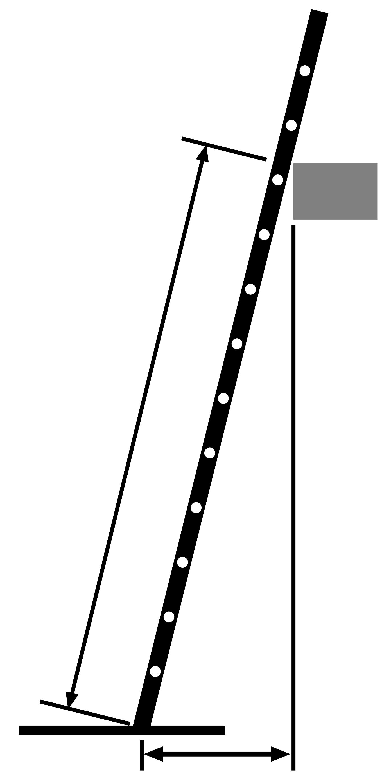
Working length of ladder
Working length of ladder divided by 4 (minimum distance)
Top support

Foot of ladder

